Player Height Analysis

**Purpose:** Analysis was conducted on the FIFA 2019 dataset to determine the distribution of player height, as well as to determine the percentile rank of popular players.

**Descriptive Statistics:**

-N = 18,157

-Min, 1Q, Median, Q3, Max = 61, 69, 71, 73, 81

-Mean, Standard Deviation = 71.4, 2.64

-Boxplots shows relatively symmetric data with no apparent skewness, outliers are identified on both sides of the IQR.

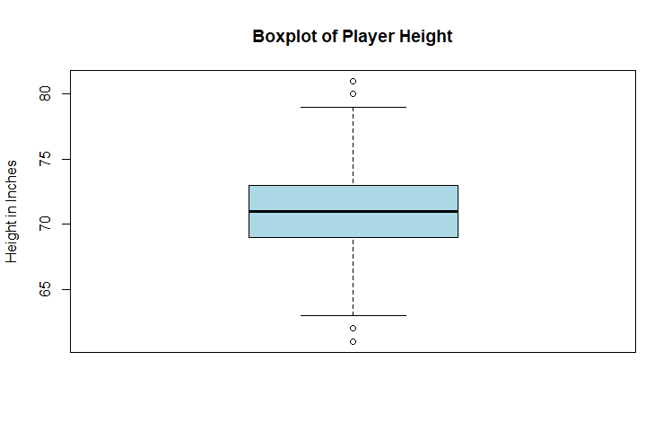

-Histogram shows a possible bimodal distribution

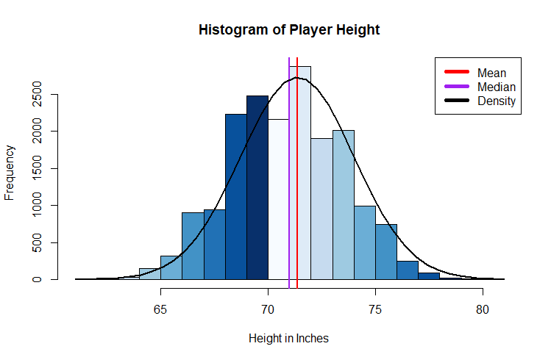

-Quantile plot shows a slight tendency of a density curve to over estimate percentile rank for values below the mean while over ranking values above the mean.

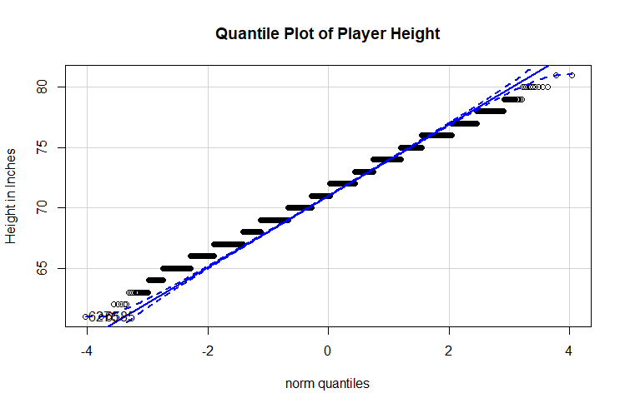

**Analysis:** A density curve is not the robust method for analyzing the height percentiles of FIFA Players, however it is close enough to allow for statistical inferences to be made.

**Insights:**

Percentile heights of popular players:

1. Messi is shorter than 95% of players
2. Ronaldo is taller than 84% of players
3. Neymar is taller than only 19% of players

Additional exploratory insights:

1. The probability of someone being Messi’s height is 4%
2. A player who is 71 is taller than exactly half of all soccer players
3. At a height of 80 inches, Lebron James would be taller than 99.9% of all soccer players